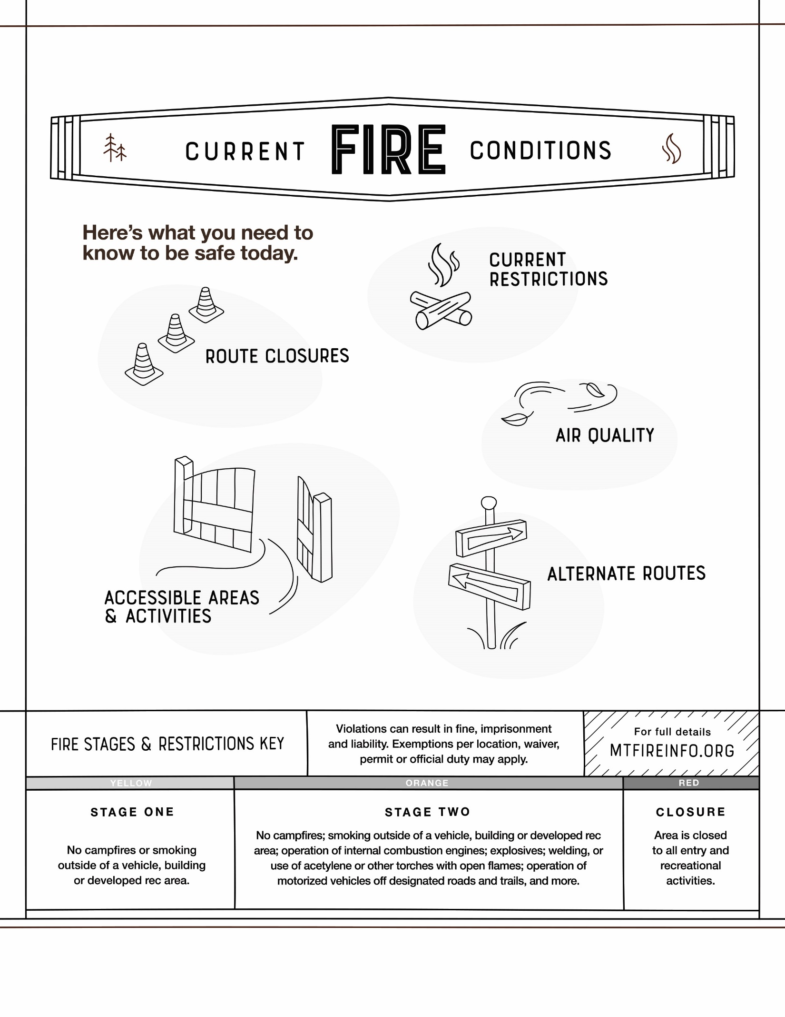
Find the latest fire details at [URL].
[ INSERT AREAS AND ACTIVITIES HERE ]
[ INSERT ROUTES HERE ]
[ INSERT AIR QUALITY DETAILS HERE ]
[ INSERT CURRENT FIRE STAGE
1,2 OR CLOSURE HERE ]
[ INSERT LOCATIONS HERE ]
UPDATED: TODAY’S DATE AT TIME
City, Montana
INSERT PARTNER LOGO HERE

