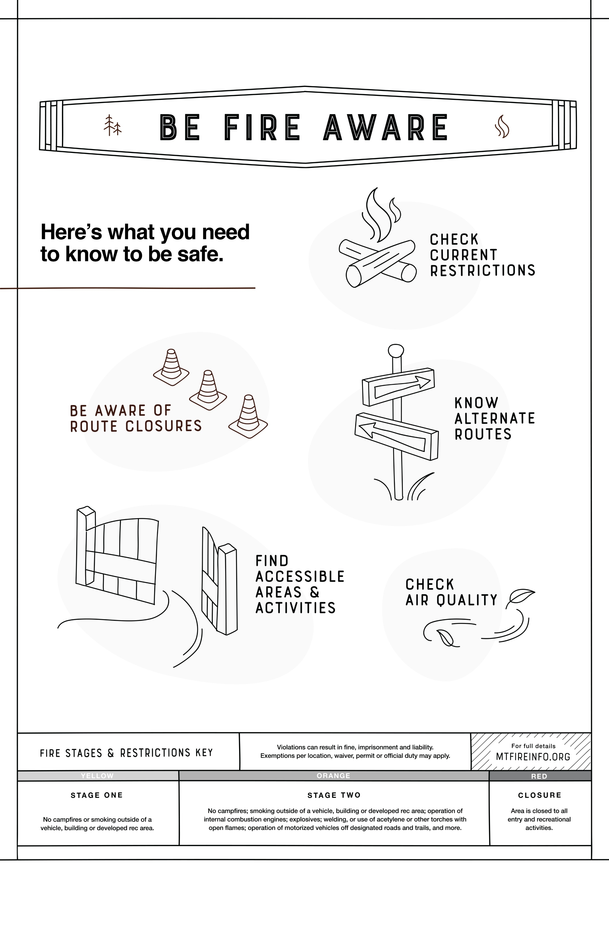
INSERT PARTNER LOGO HERE

City, Montana
Find the latest fire details at [URL].

