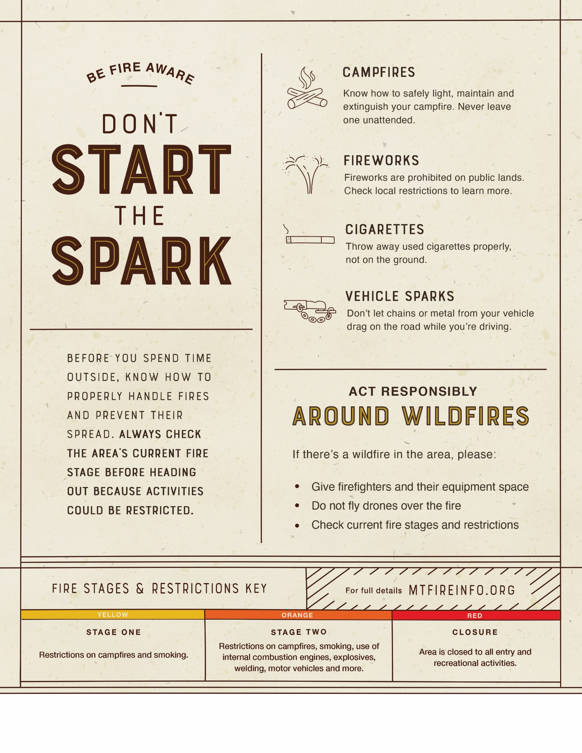
Find the latest fire details at [URL].
INSERT PARTNER LOGO HERE

