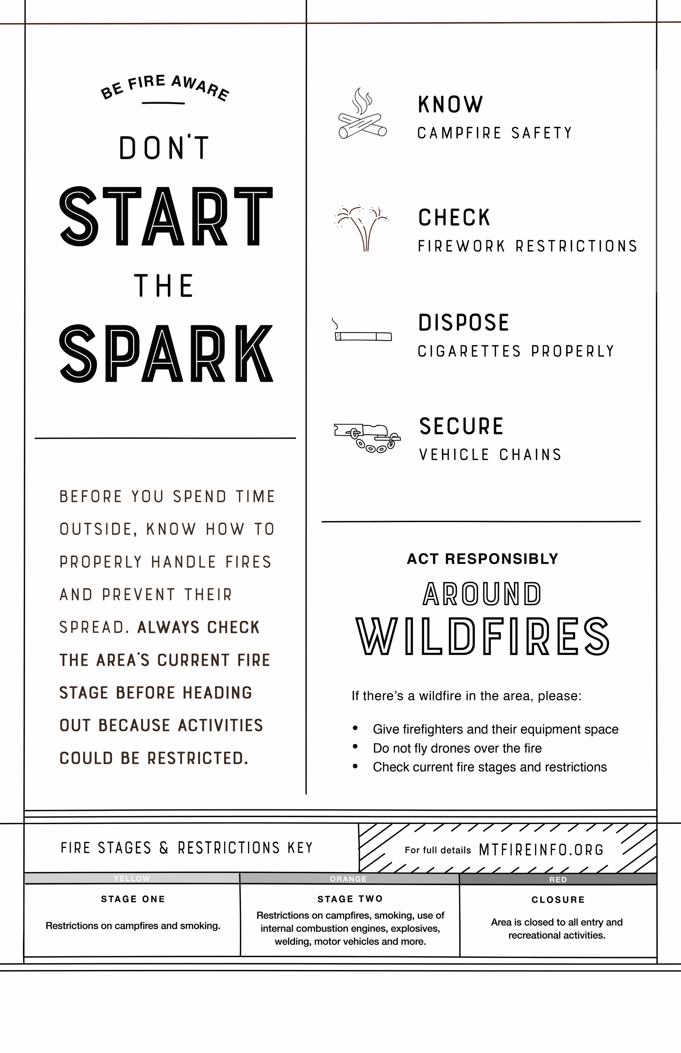
INSERT PARTNER LOGO HERE
Find the latest fire details at [URL].

