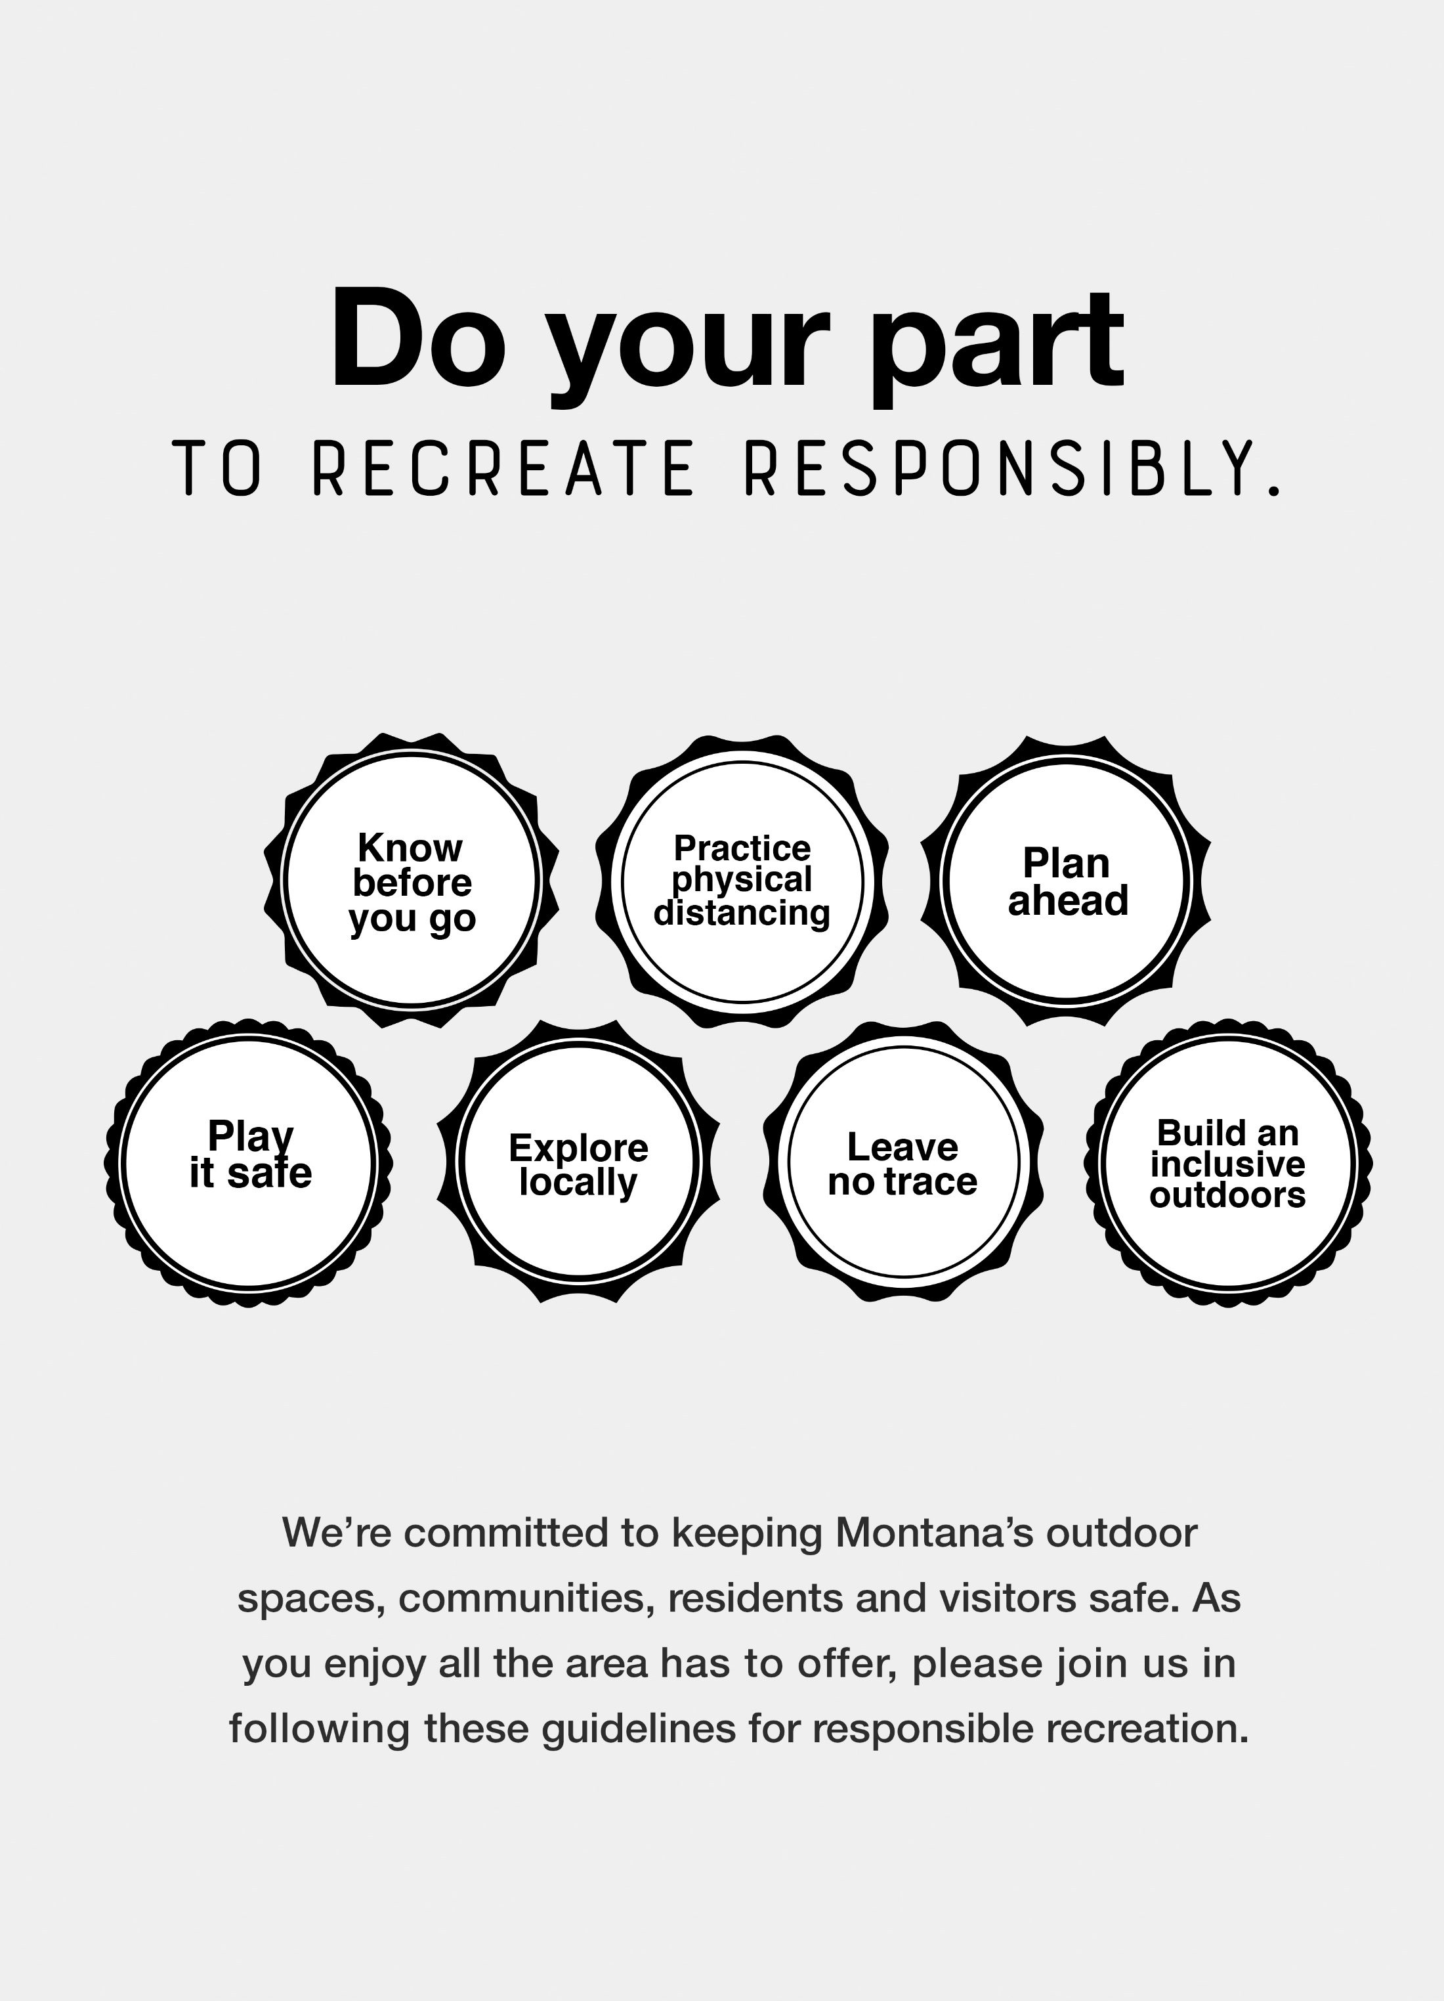
INSERT PARTNER LOGO HERE
RECREATERESPONSIBLY.ORG
OR PARTNER URL

