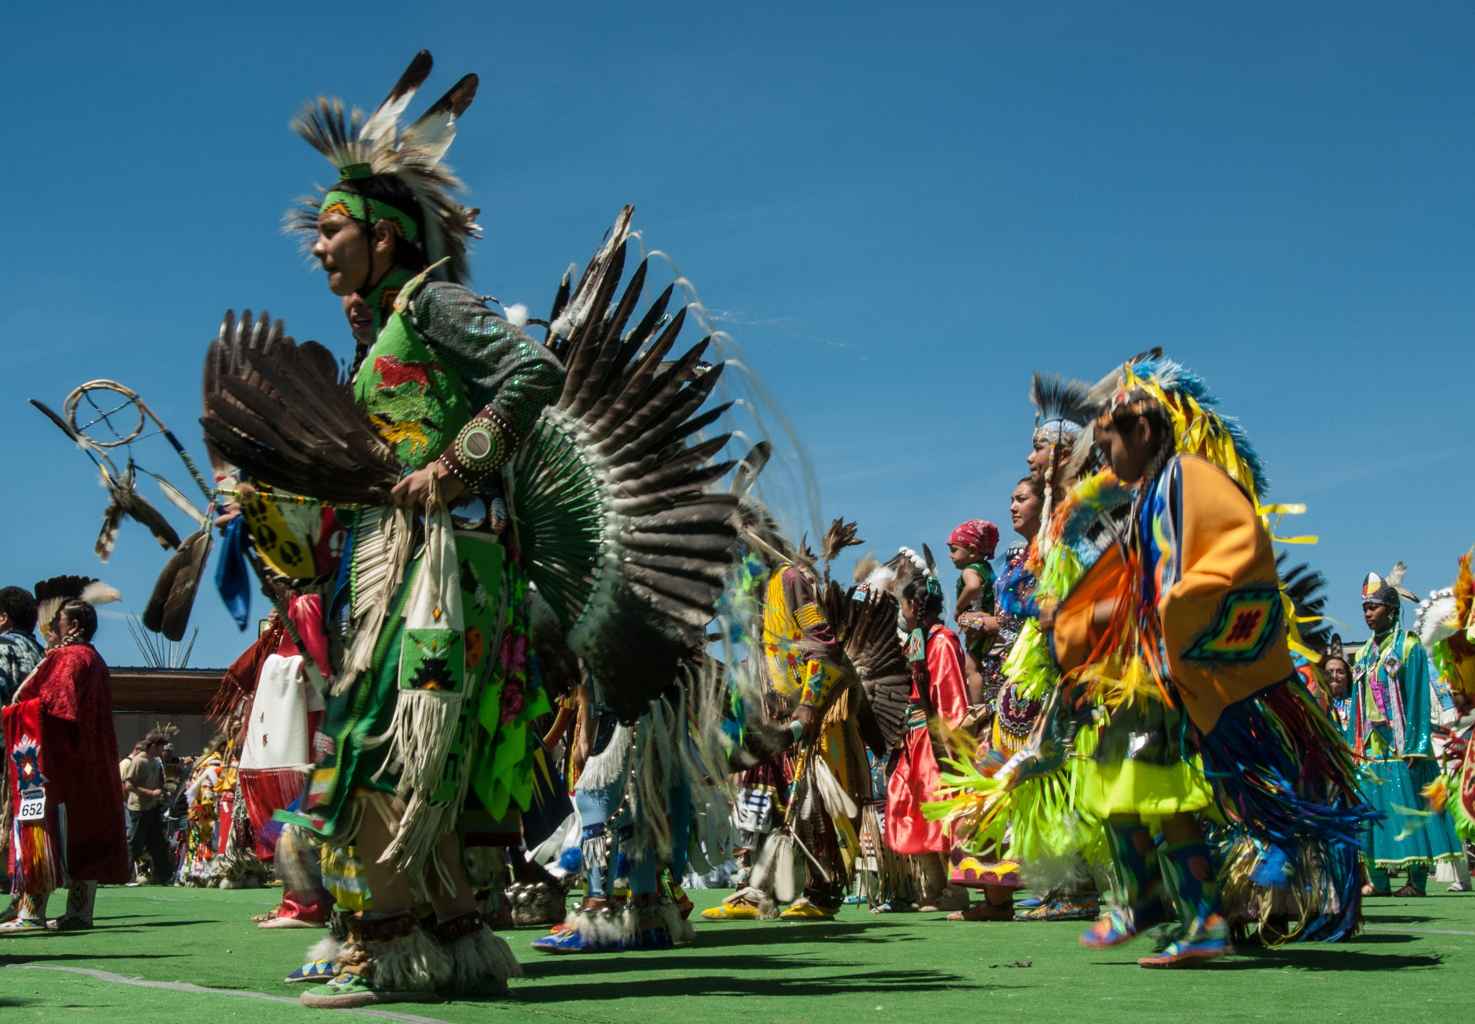



Montana Department of Commerce Tribal Tourism Grant

**Business MT Division Application Guidelines**

**BLACKFEET INDIAN RESERVATION**

Table of Contents

I. About the Program 2

II. Program Calendar 3

III. Tribal Tourism Grant 3

A. Summary 3

B. Eligible Applicants 4

C. Ineligible Applicants 4

D. Funding Availability 4

E. Eligible Tribal Tourism Projects 5

F. Ineligible Activities 6

G. Match Requirement 6

H. How to Apply 6

I. Application Review Process 7

J. Application Review Criteria 7

K. Grant Notification and Contract 8

L. Disbursement of Funds 8

M. Reporting Requirements 9

N. Program Contact 9

# I. About the Program

The Indian Country Economic Development Program, created by the 59th Montana State Legislature in 2005, is a State-funded program administered by the Montana Department of Commerce. Between October 2005 and June 2023, the Montana Legislature funded ICED with a restricted, one-time only appropriation. Since July 2023, the Montana Legislature has made a permanent annual appropriation of funds to the ICED Program for Montana’s tribal nations and tribal businesses to further business development activities in the amount of $875,000.

Various programs are administered under the ICED Program, including:

* The Tribal Business Development Grant
* The Tribal Tourism Grant
* The Indian Equity Fund Small Business Grant
* The Native American Business Advisors

These programs allow the Office of Indian Country Economic Development at Commerce to continue to articulate measurable successes of the program to tribal communities, the Executive Branch, and to elected leadership.

The Indian Country Tourism activity functions are administered by Commerce (90-1-104, MCA), to advance tourism development priorities for Montana’s tribes through funding under tribal tourism as authorized by 15-65-121(2)(h), MCA. Activities are funded through a 0.5% allocation of Montana’s Lodging Facility Use Tax collections.

As the designated seventh tourism region in Montana, Indian Country’s Tribal Tourism Program objectives, goals, strategies and metrics focus on elevating the brand, expanding opportunities and inspiring visitation to the eight tribal nations.

The Tribal Tourism Grant Program, under the direction of Commerce’s Business MT Division, OICED, the State-Tribal Economic Development Commission and the Tourism Advisory Council, administers tourism development and promotion activities on behalf of the Indian Tourism Region.

# II. Program Calendar

The following shows the proposed activities and general timelines for the Tribal Tourism Grant Program process. The timelines may vary a little from year to year. Interested persons are highly encouraged to check the TTG page on Commerce’s website for the annual deadlines: [commerce.mt.gov/business/indian-country/tribal-tourism](https://commerce.mt.gov/Business/Indian-Country/Tribal-Tourism).

|  |  |
| --- | --- |
| Oct. 1-Nov. 30, 2025 | ServiceNow Grant Application Portal open for applications |
| Dec. 1-31, 2025 | Rank and review of applications, recommendation of award to director and governor |
| Jan. 1-March 1, 2026 | Director and governor finalize awards, contract drafting |
| March 1-April 1, 2026 | Contract legal review and award letter drafting |
| April 1-May 1, 2026 | Award letters sent, awards announced in press release, and contracts executed by all parties |

This schedule is subject to change.

# III. Tribal Tourism Grant

## A. Summary

The Tribal Tourism Grant is a competitive grant program to connect participating tribes of Montana with the resources necessary to advance one or more self-identified tourism priorities. Approximately $150,000 is available to fund projects defined under Section E, “Eligible Tribal Tourism Projects” on an annual basis.

## B. Eligible Applicants

Governing bodies of the federally recognized tribes in Montana are eligible to apply and receive TTG funds. Any applicant in arrears or default with the State of Montana, including State-administered programs, is ineligible. Applicants must establish an OKTA account to access the application portal, by following these instructions: [business.mt.gov/_shared/iced/docs/tbdg/oktainstructions.pdf](https://business.mt.gov/_shared/ICED/docs/TBDG/OktaInstructions.pdf).

## C. Ineligible Applicants

Nonprofits are ineligible to apply. This program is not intended for tribal member-owned small businesses or for economic development activities not related to tourism. However, tourism-related tribal member-owned small business projects may be eligible under the Indian Equity Fund and Tribal Tourism Small Business Grant programs administered by Commerce.

## D. Funding Availability

Applications will be accepted on an open-cycle basis as outlined above in the program calendar. Please visit the ServiceNow Grant and Loans application platform for more specific deadline details: [montana.servicenowservices.com/mtgl](https://montana.servicenowservices.com/mtgl).

The total budget for the program is approximately $150,000. Applicants may request a maximum of $50,000; however, actual grant awards may be less than requested. For this reason, the Program encourages applicants to consider contingency funding sources when preparing their project budgets. Actual grants will depend on the number of applications received and the discretion of Commerce.

## E. Eligible Tribal Tourism Projects

The applicant’s project must be either (1) destination development and infrastructure updates or (2) product development and technology systems. Eligible project activities must be shovel-ready and long-lasting. Examples of eligible project activities include, but are not limited to:

1. **Destination development and infrastructure upgrades**

* Establish new or improve existing campgrounds, expand rental features like tipi rentals, small cabins and/or RV parks with upgraded amenities like electrical hookups, potable water, grey water disposal, restroom facilities, showers, picnic pavilions, fire rings, tent pads, camp host residence, facilities maintenance equipment and/or vehicles, gift shop or visitors center with point-of-sale system for purchases.
* Install historical markers with shaded areas for travelers to stop and rest, access potable water and/or use the restroom at a vault toilet.
* Interpretive trails with informational kiosks on flora, fauna or historical significance.
* Offer agritourism activities such as certified guided fishing, hiking, hunting, horseback riding, bird watching, stargazing, Bison Range tours, bicycle tours or boat tours.
* Improve ADA accessibility at existing locations.

1. **Product development and technology systems**

* Offer certified guide curriculum and course certification program at a tribally owned college or within the tribe’s historic preservation department.
* Establish a tribal tourism website where visitors can explore offerings, view a frequently asked questions section, see a map of locations and promoted events like pow wows and Indian Relay Races, check posted travel alerts, use a booking system for tours or campground reservations and make electronic payments.

## F. Ineligible Activities

Examples of ineligible activities that will not be funded include:

* Reimbursement for activities completed prior to date of application submission
* Reimbursement for activities not related to the TTG contract scope of work
* Duplicative reimbursement for activities receiving funding for the same services, equipment or improvements through any other local, state or federal grant or funding program, except as necessary to fully fund the project
* Wages, meals, transportation, lodging and mileage reimbursements
* Land and livestock purchases

## G. Match Requirement

Qualified applicants must demonstrate a combination of cash, equipment and in-kind match of actual and committed money invested in the proposed project. The match requirement is a minimum of 50% of the award total, $1 applicant to $2 award. Reasonable in-kind services, in-kind labor and/or volunteer hours and committed cash are eligible for the match requirement; however, cash match must be no less than 50% of the required match. For example: An applicant requesting a $6,000 grant award must demonstrate they have $3,000 matching where at least $1,500 is a cash match, and $1,500 in-kind and/or equipment committed to the completion of the project as match.

## H. How to Apply

Applications must be completed online through the Montana Grants and Loans Portal located at [montana.servicenowservices.com/mtgl](https://montana.servicenowservices.com/mtgl).

Applicants will be required to create an OKTA profile which requires a valid email account. OKTA is located at [okta.loginmt.com](https://okta.loginmt.com/).

Applications considered incomplete or ineligible can be reopened for editing and negotiated from the Program back to the applicant through ServiceNow during the open cycle period. Applicants are encouraged to apply early so they may make any necessary adjustments or changes before the deadline to make their application competitive. Receipt of an application does not imply a commitment of funding from Commerce. Applications will be reviewed for eligibility and compliance with state and program requirements. Applications will be reviewed by Commerce.

## I. Application Review Process

1. **Receipt of Application:** Once submitted, each application is assessed for completeness and clarity by Commerce. Commerce may contact the applicant to request additional information during the review process to aid in the evaluation process.
2. **Review:** Commerce makes funding recommendations to the director, who makes the award decision. Awards are finalized by the governor, whose office issues award letters.

## J. Application Review Criteria

Because this is a competitive grant program, each application is evaluated for its strengths and weaknesses compared to other applications. Review criteria include:

* How well does the applicant define the scope, budget and objectives of the project?
* What challenges must be mitigated to ensure the project’s success?
* How will the project positively impact tourism for the tribal community?
* How well does the project align with and support the tribe’s greater economic development plans?
* How will the success of the project be measured?
* Has the applicant successfully completed prior TTG projects and TTG contract requirements?

## K. Grant Notification and Contract

Applications are reviewed during December; recommendations for awards begin in January. The review and award process takes approximately 30-90 days. Commerce aims to notify applicants of award decisions by the end of March. The contracting process is expected to be completed no later than May 31. The projects must be completed within 24 months from the date the contract is fully executed. Commerce will consider extensions on a case-by-case basis that must be approved through a contract amendment.

## L. Disbursement of Funds

Grant funds are paid on a reimbursement basis. No funds are paid directly upfront to grantees. Grant funds are intended to be expended within two years of the contract’s start date.

Grant funds are reimbursed to the grantee with the submission of the following complete documentation:

* W-9 (with first request only if not already on file)
* EFT Form with banking information or mailing address (with first request only)
* Completion and submission of required forms and related receipts:
  + Request for Reimbursement Form
  + Project Receipt Worksheet with receipts
  + Project Status Update Report

Forms are available for download at [indiancountry.mt.gov](https://commerce.mt.gov/Business/Indian-Country/).

## M. Reporting Requirements

Project progress reports, status updates, project completion closeout form and reporting are as follows:

1. **Project progress reports and status updates:** During the term of the TTG contract, the grantee will submit project progress reports to Commerce in conjunction with each request for reimbursement. These forms will be available for download from Commerce’s website.
2. **Project completion and closeout form and reporting:** Upon completion of the project or within two years from the TTG contract execution, whichever occurs first, the grantee must submit their final Project Completion and Closeout Form for Commerce review. Upon approval of the Project Completion and Closeout Report, Commerce will issue the grantee a notice of project closeout.

## N. Program Contact

Rachelle Brown

Tribal Tourism Officer

Office of Indian Country Economic Development

Montana Department of Commerce

P.O. Box 200533

301 S. Park Ave.

Helena, MT 59620-0533

Phone: 406-841-2734

Email: rachelle.brown@mt.gov

Website: [indiancountry.mt.gov](http://www.indiancountry.mt.gov/)