Business Plan for a Startup/Expanding Business
The business plan consists of a narrative and several financial worksheets. The narrative template is the body of the business plan. It contains more than 150 questions divided into several sections. Work through the sections in any order that you want, except for the Executive Summary, which should be done last. Skip any questions that do not apply to your type of business. When you are finished writing your first draft, you’ll have a collection of small essays on the various topics of the business plan. Then you’ll want to edit them into a smooth-flowing narrative.
The real value of creating a business plan is not in having the finished product in hand; rather, the value lies in the process of researching and thinking about your business in a systematic way. The act of planning helps you to think things through thoroughly, study and research if you are not sure of the facts, and look at your ideas critically. It takes time now, but avoids costly, perhaps disastrous, mistakes later.

Business Plan

OWNER
Insert your logo here

Your Business Name
Street Address
Address 2
City, ST ZIP Code
Telephone
E-Mail
Website

Table of Contents
I. Table of Contents 3
II. Executive Summary 4
III. General Company Description 6
IV. Products and Services 7
V. Marketing Plan 8
VI. Operational Plan 16
VII. Management and Organization 20
VIII. Personal Financial Statement 21
IX. Startup Expenses and Capitalization 22
X. Financial Plan 23
XI. Appendices 27
XII. Refining the Plan 28

Executive Summary
Write this last! Writing it last is a summary of what you have already written. Include everything that you would cover in a three-minute interview.

Introduction

Problem

Describe the pain that you're alleviating. The goal is to get everyone nodding and "buying in”. Avoid looking like a solution searching for a problem. A purchase is made ONLY when a problem exists.

Solution
Explain how you alleviate this pain and the meaning that you make. Ensure that the audience clearly understand what you sell and your value proposition. No in-depth explanation. Provide the basics of how you fix the pain. Example: "We are a discount travel Web Site. We have written software that searches all other travel sites and collates their price quotes into one report."

Business Model

Explain how you make money: who pays you, your channels of distribution, and your gross margins. Generally, a unique, untested business model is a scary proposition. If you truly have a revolutionary business model, explain it in terms of familiar ones. This is your opportunity to drop the names of the organization that are already using your product or service.

Underlying Magic
Describe the technology, secret sauce, or magic behind your product or service. The less text and the more diagrams, schematics and flowcharts the better. What do you have that makes your better?

Marketing & Sales
Explain how you are going to reach your customer and keep them coming & bringing others. Convince the audience that you have an effective go to market strategy that won't break the bank.

Competition
Provide a complete view of the competitive landscape. Too much is better than too little. Never dismiss your competition. Everyone – (customer, investors, lenders, employees) - wants to hear why you are good, not why the competition is bad.

Management Team
Describe the key players of your management team, board of directors, and board of advisors, as well as your major investors. Don't be afraid to show up with less than a perfect team. All start-ups have holes their team - what's truly important is whether you understand that there are holes and are willing to fix them.

Financial Projections & Key Metrics
Provide a five-year forecast containing not only dollars but also key metrics, such as number of customers and conversion rate. Consider long sales cycles and seasonality. Making people understand the underlying assumption of your forecast is as important as the number themselves

Status, Accomplishments to Date, Timeline & Use of Funds
Explain the status of your product/service, what the near future looks like. Share the details of your positive momentum and traction. Include what action should be taken next. If asking for financing, state clearly how much you want, precisely how you are going to use it, and how the money will make your business more profitable, thereby ensuring repayment.

General Company Description
What business will you be in? What will you do?
Mission Statement: Many companies have a brief mission statement, usually in 30 words or fewer, explaining their reason for being and their guiding principles. If you want to draft a mission statement, this is a good place to put it in the plan, followed by:
Company Goals and Objectives: Goals are destinations—where you want your business to be. Objectives are progress markers along the way to goal achievement. For example, a goal might be to have a healthy, successful company that is a leader in customer service and that has a loyal customer following. Objectives might be annual sales targets and some specific measures of customer satisfaction.
Business Philosophy: What is important to you in business?
To whom will you market your products? (State it briefly here—you will do a more thorough explanation in the Marketing Plan section).
Describe your industry. Is it a growth industry? What changes do you foresee in the industry, short term and long term? How will your company be poised to take advantage of them?
Describe your most important company strengths and core competencies. What factors will make the company succeed? What do you think your major competitive strengths will be? What background experience, skills, and strengths do you personally bring to this new venture?
Legal form of ownership: Sole proprietor, Partnership, Corporation, Limited liability corporation (LLC)? Why have you selected this form?
Exit Strategy: Provide details regarding how you plan to leave your business. Will you transfer ownership to employees or family, sell, close, or mentor a replacement?

Products and Services
Describe in depth your products or services (technical specifications, drawings, photos, sales brochures, and other bulky items belong in Appendices).
What factors will give you competitive advantages or disadvantages? Examples include level of quality or unique or proprietary features.
What are the pricing, fee, or leasing structures of your products or services?

Marketing Plan

Market research - Why?
No matter how good your product and your service, the venture cannot succeed without identifying and understanding your market. You need to do market research to make sure you’re on track. Use the business planning process as your opportunity to uncover data and to question your marketing efforts. Your time will be well spent.

Market research - How?
There are two kinds of market research: primary and secondary.
Secondary research means using published information such as industry profiles, trade journals, newspapers, magazines, census data, and demographic profiles. This type of information is available in public libraries, industry associations, chambers of commerce, from vendors who sell to your industry, and from government agencies.
Primary research means gathering your own data.

Economics
Facts about your industry:
- What is the total size of your market?
- What percent share of the market will you have? (This is important only if you think you will be a major factor in the market.)
- Current demand
- Trends in target market—growth trends, trends in consumer preferences, and trends in product development.
- Growth potential and opportunity for a business of your size.
- What barriers to entry do you face in entering this market with your new company? Some typical barriers are:
- High capital costs
- High production costs
- High marketing costs
- Consumer acceptance and brand recognition
- Training and skills
- Unique technology and patents
- Unions
- Shipping costs
- Tariff barriers and quotas
- And of course, how will you overcome the barriers?
- How could the following affect your company?
- Change in technology
- Change in government regulations
- Change in the economy
- Change in your industry

Product
In the Products and Services section, you described your products and services as you see them. Now describe them from your customers’ point of view.
Features and Benefits
List all your major products or services.
For each product or service:
- Describe the most important features. What is special about it?
- Describe the benefits. That is, what will the product do for the customer?
Note the difference between features and benefits, and think about them. For example, a house that gives shelter and lasts a long time is made with certain materials and to a certain design; those are its features. Its benefits include pride of ownership, financial security, providing for the family, and inclusion in a neighborhood. You build features into your product so that you can sell the benefits.
What after-sale services will you give? Some examples are delivery, warranty, service contracts, support, follow-up, and refund policy.

Customers
Identify your targeted customers, their characteristics, and their geographic locations, otherwise known as their demographics.
The description will be completely different depending on whether you plan to sell to other businesses or directly to consumers. If you sell a consumer product, but sell it through a channel of distributors, wholesalers, and retailers, you must carefully analyze both the end consumer and the middleman businesses to which you sell.
You may have more than one customer group. Identify the most important groups. Then, for each customer group, construct what is called a demographic profile:
- Age
- Gender
- Location
- Income level
- Social class and occupation
- Education
- Other (specific to your industry)
For business customers, the demographic factors might be:
- Industry (or portion of an industry)
- Location
- Size of firm
- Quality, technology, and price preferences
- Other (specific to your industry)

Location (sample for Billings is provided)

Billings, located in Yellowstone County, is the most populous area in a 500-mile radius and the amount of people from the surrounding areas that travel to this “hub” for its services and amenities is remarkable. This area offers many qualities key to economic success, including a solid, hard-working and educated workforce; lower than national costs of utilities along with wage; and an unquestionably pro-business environment. Billings is energized. It embraces its history, but looks forward to the future.
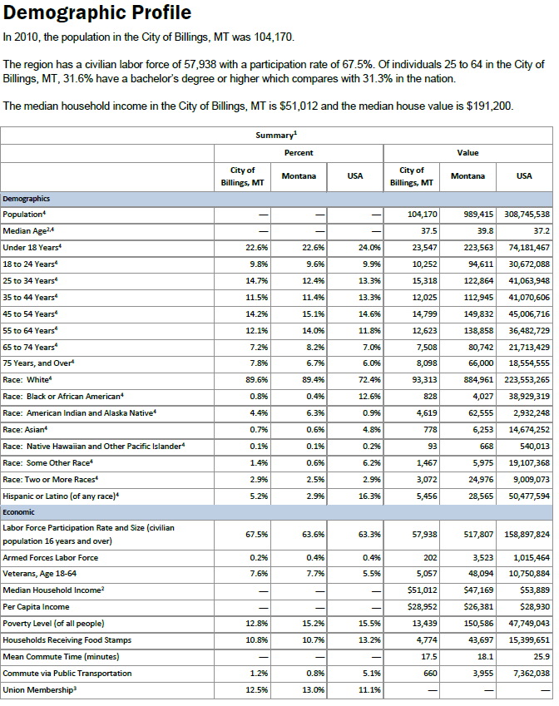
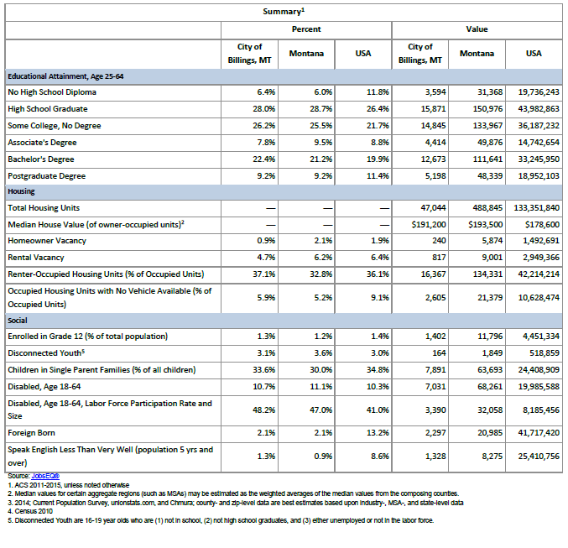
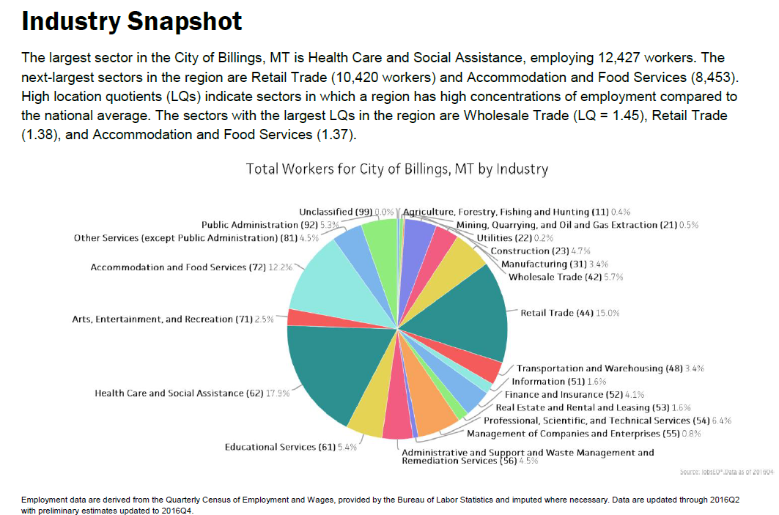

Sectors in the City of Billings, MT with the highest average wages per worker are Mining, Quarrying, and Oil and Gas Extraction ($100,523), Utilities ($83,411), and Finance and Insurance ($67,610). Regional sectors with the best job growth (or most moderate job losses) over the last 5 years are Accommodation and Food Services (+1,124 jobs), Health Care and Social Assistance (+785), and Retail Trade (+661).

Over the next 10 years, employment in the City of Billings, MT is projected to expand by 7,043 jobs. The fastest growing sector in the region is expected to be Health Care and Social Assistance with a +1.8% year-over-year rate of growth. The strongest forecast by number of jobs over this period is expected for Health Care and Social Assistance (+2,418 jobs), Retail Trade (+960), and Accommodation and Food Services (+701).
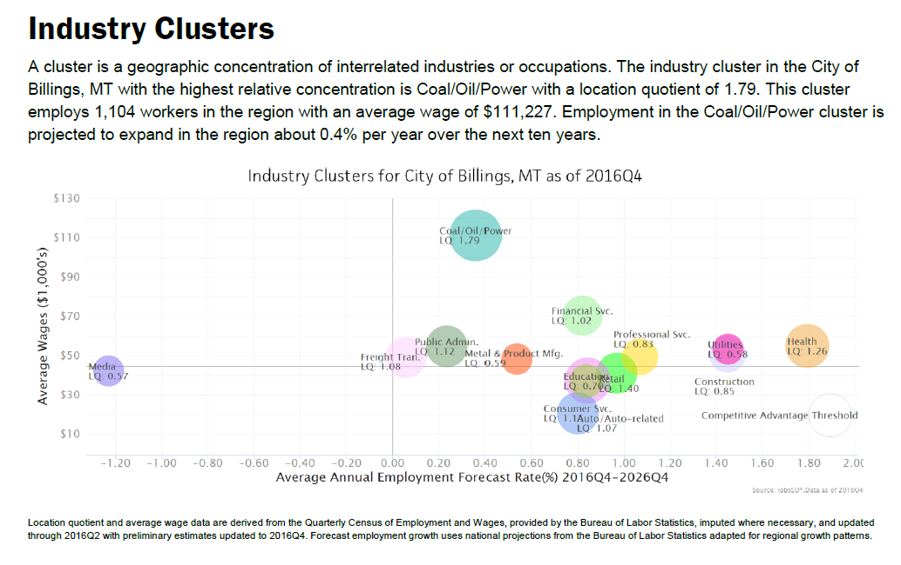
Expand data for your specific address (traffice counts and so forth)

Competition
What products and companies will compete with you?
List your major competitors:
(Names and addresses)
Will they compete with you across the board, or just for certain products, certain customers, or in certain locations?
Will you have important indirect competitors? (For example, video rental stores compete with theaters, although they are different types of businesses.)
How will your products or services compare with the competition?
Now analyze each major competitor. In a few words, state how you think they compare.
Now, write a short paragraph stating your competitive advantages and disadvantages.

Niche
Now that you have systematically analyzed your industry, your product, your customers, and the competition, you should have a clear picture of where your company fits into the world.
In one short paragraph, define your niche, your unique corner of the market.

Strategy
Now outline a marketing strategy that is consistent with your niche. You may consider utilizing the services of a Marketing Firm to assist you in developing this section.
Promotion (advertising)
How will you get the word out to customers?
Advertising: What media, why, and how often? Why this mix and not some other?
Have you identified low-cost methods to get the most out of your promotional budget?
Will you use methods other than paid advertising, such as trade shows, catalogs, dealer incentives, word of mouth (how will you stimulate it?), and network of friends or professionals?
What image do you want to project? How do you want customers to see you?
In addition to advertising, what plans do you have for graphic image support? This includes things like logo design, cards and letterhead, brochures, signage, and interior design (if customers come to your place of business).
Should you have a system to identify repeat customers and then systematically contact them?
Promotional Budget
How much will you spend on the items listed above?
Before startup? (These numbers will go into your startup budget.)
Ongoing? (These numbers will go into your operating plan budget.)
Pricing
Explain your method or methods of setting prices. For most small businesses, having the lowest price is not a good policy. It robs you of needed profit margin; customers may not care as much about price as you think; and large competitors can under price you anyway. Usually you will do better to have average prices and compete on quality and service.
Does your pricing strategy fit with what was revealed in your competitive analysis?
Compare your prices with those of the competition. Are they higher, lower, the same? Why?
How important is price as a competitive factor? Do your intended customers really make their purchase decisions mostly on price?
What will be your customer service and credit policies?
Proposed Location
Probably you do not have a precise location picked out yet. This is the time to think about what you want and need in a location. Many startups run successfully from home for a while.
You will describe your physical needs later, in the Operational Plan section. Here, analyze your location criteria as they will affect your customers.
Is your location important to your customers? If yes, how?
If customers come to your place of business:
Is it convenient? Parking? Interior spaces? Not out of the way?
Is it consistent with your image?
Is it what customers want and expect?
Where is the competition located? Is it better for you to be near them (like car dealers or fast-food restaurants) or distant (like convenience-food stores)?
Distribution Channels
How do you sell your products or services?
Retail
Direct (online)
Wholesale

Sales Forecast
Now that you have described your products, services, customers, markets, and marketing plans in detail, it’s time to attach some numbers to your plan. Use a sales forecast spreadsheet to prepare a month-by-month projection. The forecast should be based on your historical sales, the marketing strategies that you have just described, your market research, and industry data, if available.
You may want to do two forecasts: 1) a "best guess", which is what you really expect, and 2) a "worst case" low estimate that you are confident you can reach no matter what happens.
Remember to keep notes on your research and your assumptions as you build this sales forecast and all subsequent spreadsheets in the plan. This is critical if you are going to present it to funding sources.

Operational Plan
Explain the daily operation of the business, its location, equipment, people, processes, and surrounding environment.

Production
How and where are your products or services produced?
Explain your methods of:
- Production techniques and costs
- Quality control
- Customer service
- Inventory control
- Product development

Location
What qualities do you need in a location? Describe the type of location you’ll have.
Physical requirements:
- Amount of space
- Type of building
- Zoning
- Power and other utilities
Access:
Is it important that your location be convenient to transportation or to suppliers?
Do you need easy walk-in access?
What are your requirements for parking and proximity to freeway, airports, railroads, and shipping centers?
Include a drawing or layout of your proposed facility if it is important, as it might be for a manufacturer.
Construction? Most new companies should not sink capital into construction, but if you are planning to build, costs and specifications will be a big part of your plan.
Cost: Estimate your occupation expenses, including rent, but also including maintenance, utilities, insurance, and initial remodeling costs to make the space suit your needs. These numbers will become part of your financial plan.
What will be your business hours?

Legal Environment
Describe the following:
- Licensing and bonding requirements
- Permits
- Health, workplace, or environmental regulations
- Special regulations covering your industry or profession
- Zoning or building code requirements
- Insurance coverage
- Trademarks, copyrights, or patents (pending, existing, or purchased)

Personnel
- Number of employees
- Type of labor (skilled, unskilled, and professional)
- Where and how will you find the right employees?
- Quality of existing staff
- Pay structure
- Training methods and requirements
- Who does which tasks?
- Do you have schedules and written procedures prepared?
- Have you drafted job descriptions for employees? If not, take time to write some. They really help internal communications with employees.
- For certain functions, will you use contract workers in addition to employees?
- Job descriptions

Inventory
- What kind of inventory will you keep: raw materials, supplies, finished goods?
- Average value in stock (i.e., what is your inventory investment)?
- Rate of turnover and how this compares to the industry averages?
- Seasonal buildups?
- Lead-time for ordering?

Suppliers
Identify key suppliers:
- Names and addresses
- Type and amount of inventory furnished
- Credit and delivery policies
- History and reliability
Should you have more than one supplier for critical items (as a backup)?
Do you expect shortages or short-term delivery problems?
Are supply costs steady or fluctuating? If fluctuating, how would you deal with changing costs?

Credit Policies
- Do you plan to sell on credit?
- Do you really need to sell on credit? Is it customary in your industry and expected by your clientele?
- If yes, what policies will you have about who gets credit and how much?
- How will you check the creditworthiness of new applicants?
- What terms will you offer your customers; that is, how much credit and when is payment due?
- Will you offer prompt payment discounts? (Hint: Do this only if it is usual and customary in your industry.)
- Do you know what it will cost you to extend credit? Have you built the costs into your prices?
Managing Your Accounts Receivable
If you do extend credit, you should do an aging at least monthly to track how much of your money is tied up in credit given to customers and to alert you to slow payment problems. A receivables aging looks like the following table:
 | Total | Current | 30 Days | 60 Days | 90 Days | Over 90 Days
Accounts Receivable Aging

You will need a policy for dealing with slow-paying customers:
- When do you make a phone call?
- When do you send a letter?
- When do you get your attorney to threaten?
Managing Your Accounts Payable
You should also age your accounts payable, what you owe to your suppliers. This helps you plan whom to pay and when. Paying too early depletes your cash, but paying late can cost you valuable discounts and can damage your credit. (Hint: If you know you will be late making a payment, call the creditor before the due date.)
Do your proposed vendors offer prompt payment discounts?
A payables aging looks like the following table.
 | Total | Current | 30 Days | 60 Days | 90 Days | Over 90 Days
Accounts Payable Aging

Management and Organization
Who will manage the business on a day-to-day basis? What experience does that person bring to the business? What special or distinctive competencies? Is there a plan for continuation of the business if this person is lost or incapacitated?
If you’ll have more than 10 employees, create an organizational chart showing the management hierarchy and who is responsible for key functions.
Include position descriptions for key employees. If you are seeking loans or investors, include resumes of owners and key employees.

Professional and Advisory Support
List the following:
- Management advisory board
- Attorney
- CPA
- Insurance agent
- Banker
- Consultant(s)
- Mentors and key advisors

Personal Financial Statement
Include personal financial statements for each owner showing assets and liabilities held outside the business and personal net worth. Owners will often have to draw on personal assets to finance the business, and these statements will show what is available. Bankers and investors usually want this information as well.

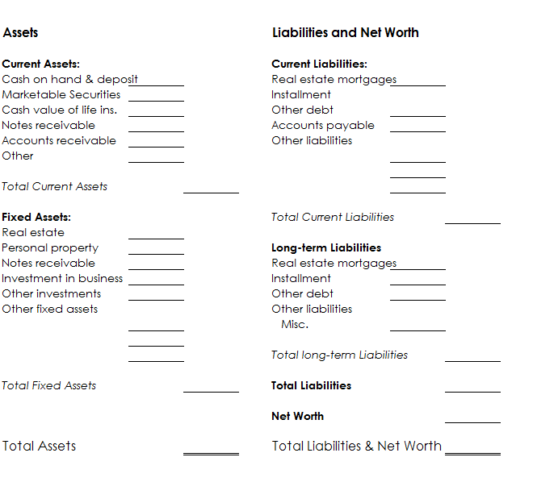

Startup Expenses and Capitalization
You will have many expenses before you even begin operating your business. It’s important to estimate these expenses accurately and then to plan where you will get sufficient capital. This is a research project, and the more thorough your research efforts, the less chance that you will leave out important expenses or underestimate them.
Talk to others who have started similar businesses to get a good idea of how much to allow for contingencies. If you cannot get good information, we recommend a rule of thumb that contingencies should equal at least 20 percent of the total of all other start-up expenses.
Explain your research and how you arrived at your forecasts of expenses. Give sources, amounts, and terms of proposed loans. Also explain in detail how much will be contributed by each investor and what percent ownership each will have.
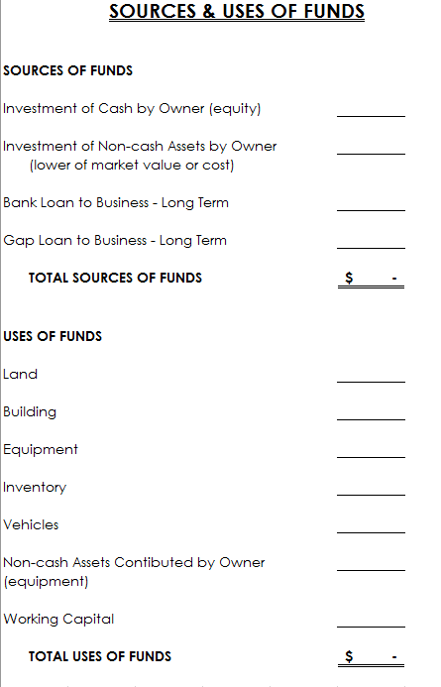

Financial Plan
The financial plan consists of a cash flow projection month by month for the first year, a first-year income statement projection, a first-year balance sheet projection and a 3-year income statement projection after start-up. Together they constitute a reasonable estimate of your company's financial future. More important, the process of thinking through the financial plan will improve your insight into the inner financial workings of your company.

Month by Month First Year Cash Flow Projection
Many business owners think of this month by month projection as the centerpiece of their plan. This is where you put it all together in numbers and get an idea of what it will take to make a profit and be successful.
Your sales projections will be based on your market research and come from a sales forecast in which you forecast how your consumer will behave and how many sales you will generate based on their behavior, the cost of goods sold, and expenses.
Profit projections should be accompanied by a narrative explaining the major assumptions used to estimate company income and expenses.
Businesses fail because they cannot pay their bills. Every part of your business plan is important, but none of it means a thing if you run out of cash.
The point of this worksheet is to plan how much you need before startup, for preliminary expenses, operating expenses, and reserves. You should keep updating it and using it afterward. It will enable you to foresee shortages in time to do something about them—perhaps cut expenses, or perhaps negotiate a loan. But foremost, you shouldn’t be taken by surprise.
For each item, determine when you expect to receive cash (for sales) or when you will have to write a check (for expense items).
You should track essential operating data, which is not necessarily part of cash flow but allows you to track items that have a heavy impact on cash flow, such as sales and inventory purchases.
You should also track cash outlays prior to opening in a pre-startup column. You should have already researched those for your startup expenses plan.
Your cash flow will show you whether your working capital is adequate. Clearly, if your projected cash balance ever goes negative, you will need more start-up capital. This plan will also predict just when and how much you will need to borrow.
Are some expenses payable in advance? When?
Are there irregular expenses, such as quarterly tax payments, maintenance and repairs, or seasonal inventory buildup, that should be budgeted?
Loan payments, equipment purchases, and owner's draws usually do not show on income statements but do take cash out. Be sure to include them.
And of course, depreciation does not appear in the cash flow at all because you never write a check for it.
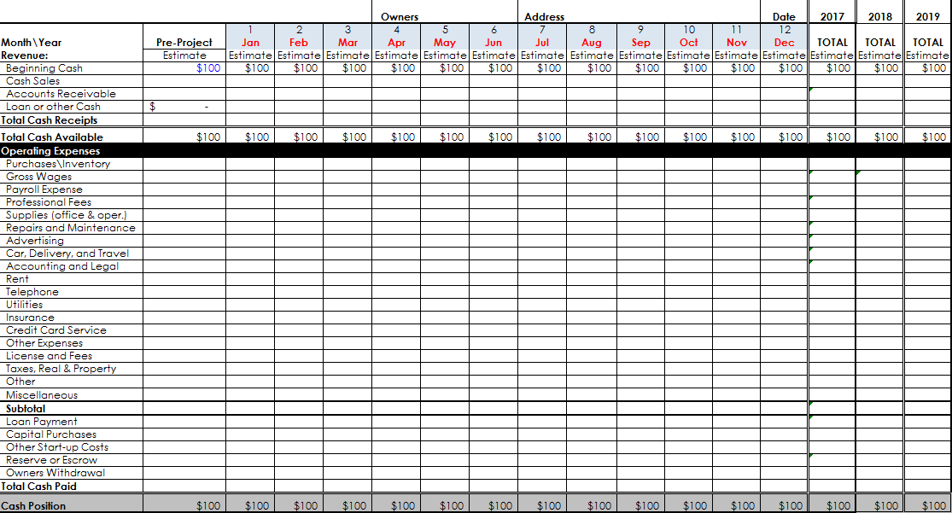

First Year Projected Income Statement
Using the totals from your cash flow projection, you can develop your projected income statement. The income statement looks at the snapshot of the businesses year and include non-cash expenses such as depreciation. This also breaks all your costs and expenses into a percent of your sales to see where your cash is going and how much.
You will replace the blank example below with your completed projection
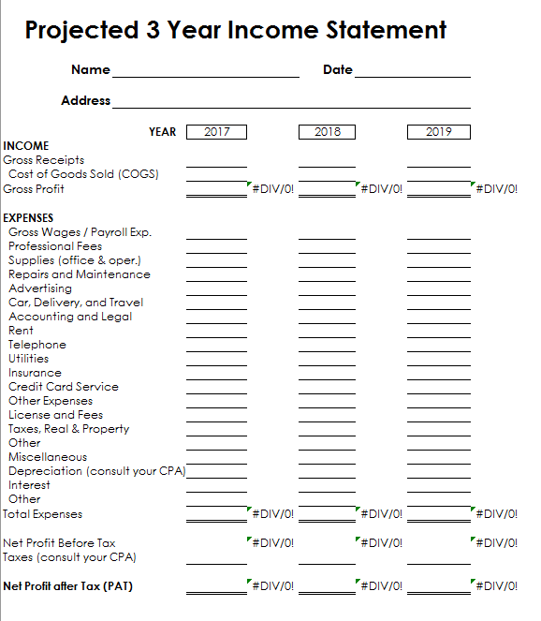

Opening Day Balance Sheet
A balance sheet is one of the fundamental financial reports that any business needs for reporting and financial management. A balance sheet shows what items of value are held by the company (assets), and what its debts are (liabilities). When liabilities are subtracted from assets, the remainder is owners’ equity.
Use a startup expenses and capitalization spreadsheet as a guide to preparing a balance sheet as of opening day. Then detail how you calculated the account balances on your opening day balance sheet.
Optional: Some people want to add a projected balance sheet showing the estimated financial position of the company at the end of the first year. This is especially useful when selling your proposal to investors.
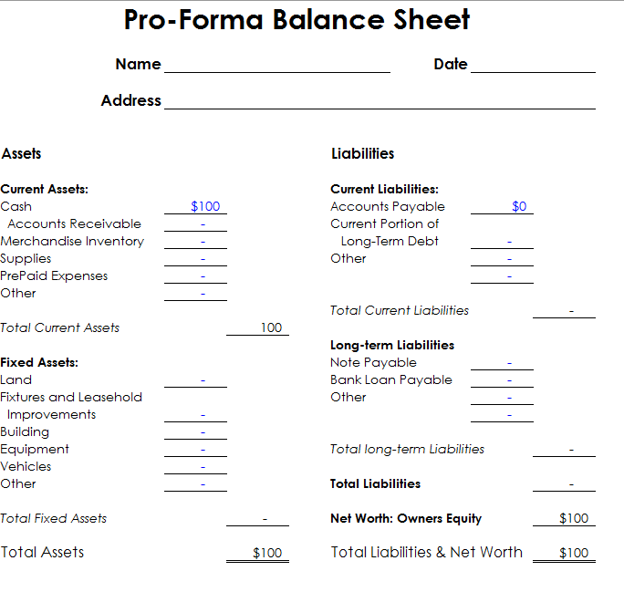

Break-Even Analysis
A break-even analysis predicts the sales volume, at a given price, required to recover total costs. In other words, it’s the sales level that is the dividing line between operating at a loss and operating at a profit.
Expressed as a formula, break-even is:
Breakeven Sales = | Fixed Costs
Breakeven Sales = | 1- Variable Costs

(Where fixed costs are expressed in dollars, but variable costs are expressed as a percent of total sales.)
Include all assumptions upon which your break-even calculation is based.
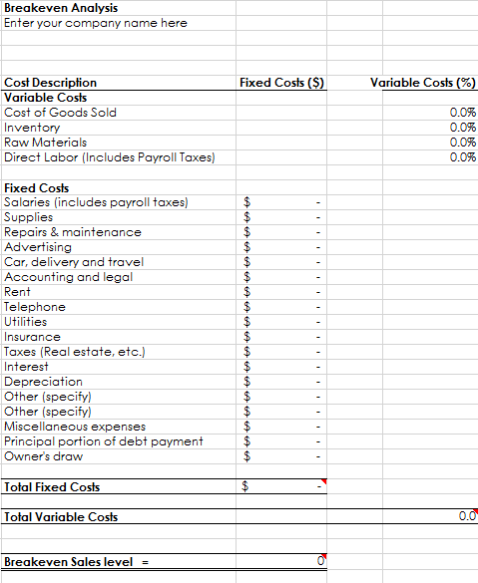

Appendices
Include details and studies used in your business plan; for example:
- Request letter for funding
- Loan package items
- Resume for owners & key employees
- Brochures and advertising materials
- Industry studies & market data reports
- Blueprints and plans
- Maps and photos of location
- Magazine or other articles
- Detailed lists of equipment owned or to be purchased
- Copies of leases and contracts
- Letters of support from future customers
- Any other materials needed to support the assumptions in this plan
- Market research studies
- List of assets available as collateral for a loan

Tips for Refining Your Plan
The generic business plan presented above should be modified to suit your specific type of business and the audience for which the plan is written.

For Raising Capital
For Bankers
- Bankers want assurance of repayment. If you intend using this plan to present to lenders, include:
- Amount of loan
- How the funds will be used
- What this will accomplish—how will it make the business stronger?
- Requested repayment terms (number of years to repay). You will probably not have much negotiating room on interest rate but may be able to negotiate a longer repayment term, which will help cash flow.
- Collateral offered, and a list of all existing liens against collateral
For Investors
- Investors have a different perspective. They are looking for dramatic growth, and they expect to share in the rewards:
- Funds needed short-term
- Funds needed in two to five years
- How the company will use the funds, and what this will accomplish for growth.
- Estimated return on investment
- Exit strategy for investors (buyback, sale, or IPO)
- Percent of ownership that you will give up to investors
- Milestones or conditions that you will accept
- Financial reporting to be provided
- Involvement of investors on the board or in management

For Type of Business
Manufacturing
- Planned production levels
- Anticipated levels of direct production costs and indirect (overhead) costs—how do these compare to industry averages (if available)?
- Prices per product line
- Gross profit margin, overall and for each product line
- Production/capacity limits of planned physical plant
- Production/capacity limits of equipment
- Purchasing and inventory management procedures
- New products under development or anticipated to come online after startup
Service Businesses
- Service businesses sell intangible products. They are usually more flexible than other types of businesses, but they also have higher labor costs and generally very little in fixed assets.
- What are the key competitive factors in this industry?
- Your prices
- Methods used to set prices
- System of production management
- Quality control procedures. Standard or accepted industry quality standards.
- How will you measure labor productivity?
- Percent of work subcontracted to other firms. Will you make a profit on subcontracting?
- Credit, payment, and collections policies and procedures
- Strategy for keeping client base
High Technology Companies
- Economic outlook for the industry
- Will the company have information systems in place to manage rapidly changing prices, costs, and markets?
- Will you be on the cutting edge with your products and services?
- What is the status of research and development? And what is required to:
- Bring product/service to market?
- Keep the company competitive?
- How does the company:
- Protect intellectual property?
- Avoid technological obsolescence?
- Supply necessary capital?
- Retain key personnel?
High-tech companies sometimes have to operate for a long time without profits and sometimes even without sales. If this fits your situation, a banker probably will not want to lend to you. Venture capitalists may invest, but your story must be very good. You must do longer-term financial forecasts to show when profit take-off is expected to occur. And your assumptions must be well documented and well argued.
Retail Business
- Company image
- Pricing:
- Explain markup policies.
- Prices should be profitable, competitive, and in accordance with company image.
- Inventory:
- Selection and price should be consistent with company image.
- Inventory level: Find industry average numbers for annual inventory turnover rate (available in RMA book). Multiply your initial inventory investment by the average turnover rate. The result should be at least equal to your projected first year's cost of goods sold. If it is not, you may not have enough budgeted for startup inventory.
- Customer service policies: These should be competitive and in accord with company image.
- Location: Does it give the exposure that you need? Is it convenient for customers? Is it consistent with company image?
- Promotion: Methods used, cost. Does it project a consistent company image?
- Credit: Do you extend credit to customers? If yes, do you really need to, and do you factor the cost into prices?

