# Funded Projects Database

The Montana Department of Commerce established the Funded Projects Database as an extension of the Transparency in Montana Government initiative. It helps Commerce provide accountability to the citizens of Montana to ensure that we are delivering efficient and effective government services. Commerce uses the database to record all requests for funding from Commerce grant and loan sources. Another function of the database is the mapping feature, which offers a visual representation of Commerce’s grants and loans.

The Funded Projects Database is located on Commerce’s website at [commerce.mt.gov/about/funded-projects](https://commerce.mt.gov/About/Funded-Projects). You can navigate to the same page by going to [commerce.mt.gov](https://commerce.mt.gov) and clicking “About” in the upper right-hand corner of the landing page:

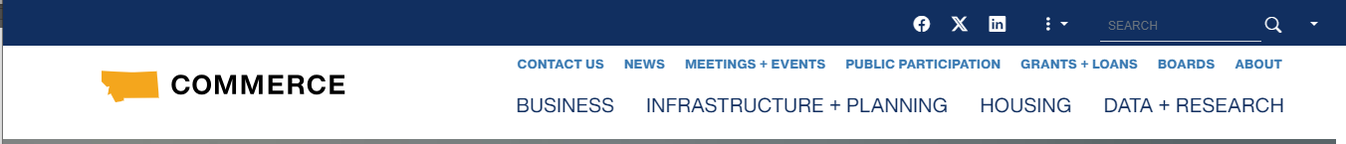

Next, click “Funded Projects” on the left-hand navigation panel:

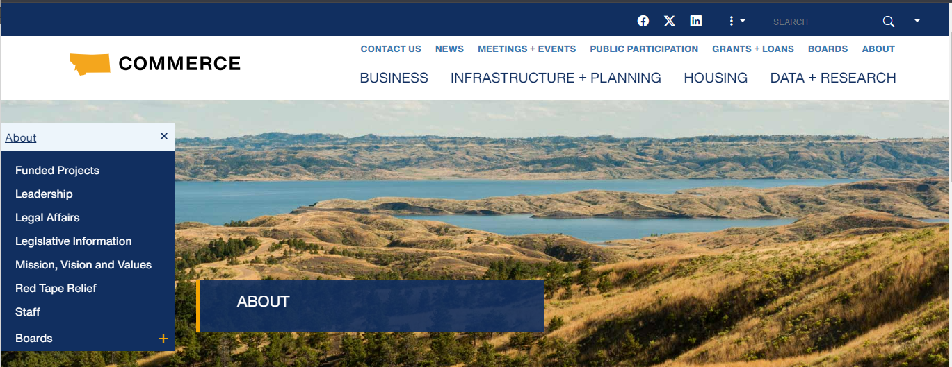

## Navigating the Database

To begin navigating the database, review the instructions:

The Montana Department of Commerce provides grants and loans to organizations and individuals across Montana.

To export this information:

1. Select the data filters needed across the top.
2. Click on the download button at the bottom.
3. Select PDF to print the information or Crosstab to download to a CSV file which can be opened in Excel. If Crosstab is not available, click on a column heading and try again.

If you have further questions or need more information, please [contact us](https://commerce.mt.gov/Contact/index).

The database has multiple filters which can be adjusted to make narrowing down results easier. These are:

a screenshot showing filter options for the Funded Projects Database at commerce.mt.gov: Division Name, Program Name, Project Status, Project Applicant, Project Name and Awarded Date: Range

Community MT is our **Division Name**.

**Program Name** contains the different funding programs housed at Commerce. This section will include Montana Main Street, the Montana Historic Preservation Grant Program and other Community MT programs.

There are several options under **Project Status**. Below is a guide to understanding what each status means:

* Submitted: A grant application has been submitted to Community MT.
* Awarded: The grant has been awarded, and the Governor’s Award Letter has been sent or legislative bill has been signed.
* Not awarded: The grant application was reviewed and not awarded/funded. The Not Funded Letter has been sent.
* Obligated: The grant contract has been executed.
* Withdrawn: The applicant has withdrawn their application.
* Terminated: The grantee or Commerce has returned or ended the grant.
* Completed: The project has been completed and contract closed out per Community MT’s procedures.
* Transferred: This status is not used by Community MT.

**Project Applicant** is the entity which applied for any grants or loans with Commerce. This may not be the same as the beneficiary. Often with Commerce grants and loans, local governments will sponsor applications and work with subrecipients for the funds. Subrecipients will be listed in the Project Description.

**Project Name** is the Commerce or division-specific naming convention for the grant or loan project.

An interactive, live map is attached to the database. The map defaults to displaying all entries in the database.

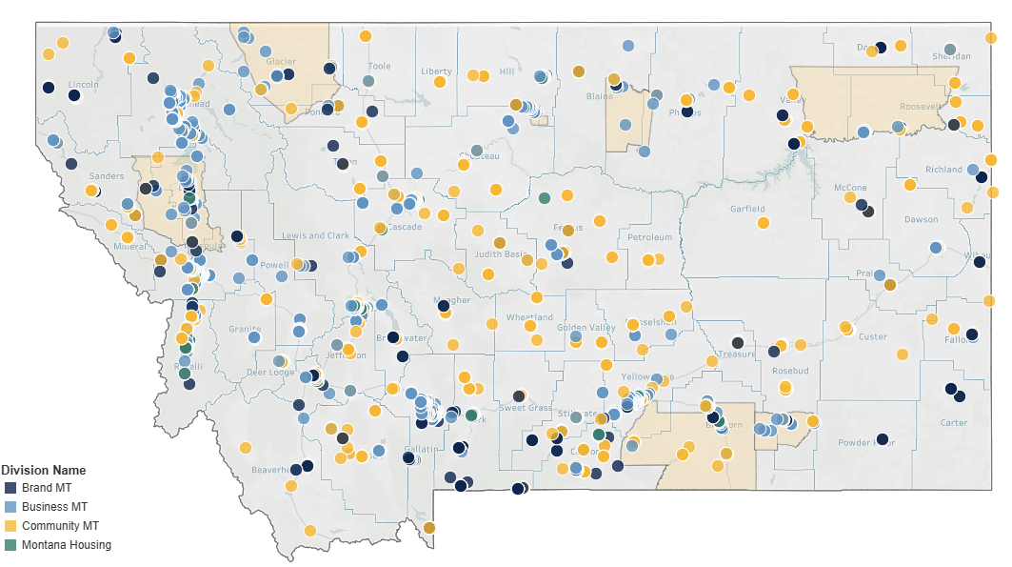

As more filters are applied when searching the database, fewer dots and symbols will populate the map.

The map legend in the lower left-hand corner of the interactive map lists the divisions of Commerce that have received applications.

## Searching for Records

When searching for specific records, it is visually cleaner to remove the filter for the program names. This will wipe the map clean of symbols.

To see all grants and loans for which a particular applicant applied with Commerce, type the applicant’s name into the **Project Applicant** text box. For cities and towns, enter the proper name and leave off “city of” or “town of.” For example, type “Helena” instead of “City of Helena.” Once you have entered “Helena,” click the search symbol or hit Enter.

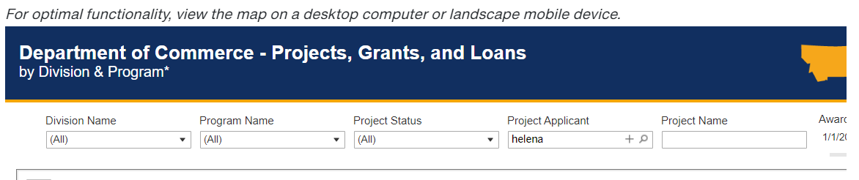

If there are multiple entries with Helena as part of project applicant’s name, a drop-down list will appear. From the drop-down list, click the box next to “Helena, City of.”

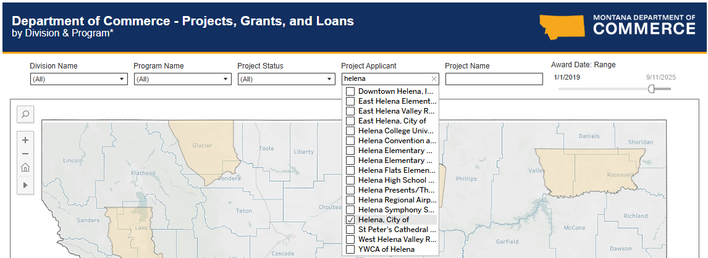

Symbols will appear on the map in Helena, along with an updated legend listing only the divisions for whose programs the City of Helena has applied. The map below shows that the City of Helena has applied to programs within the Business MT and Community MT divisions.

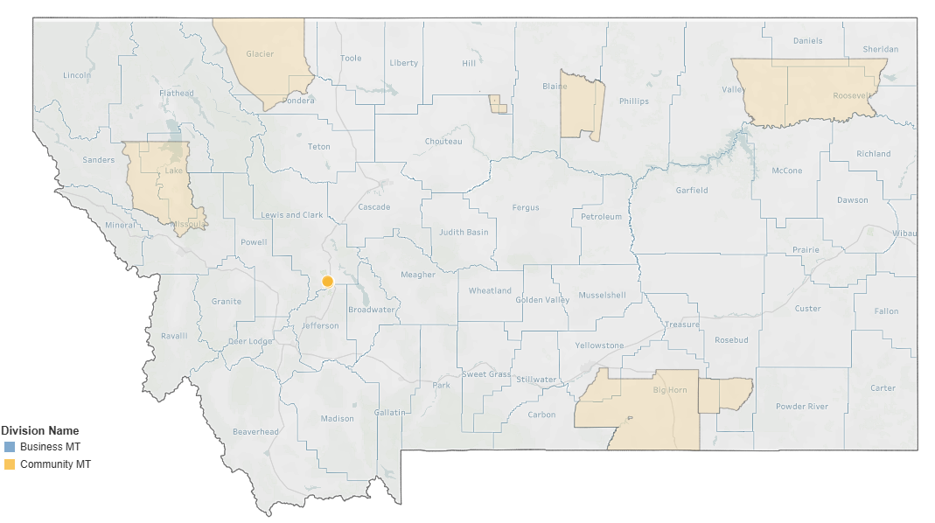

## Exporting Records

The following steps detail how to export records from searching the database. Scroll to the bottom right-hand corner of the map and click on the rectangle with a downward-pointing arrow.

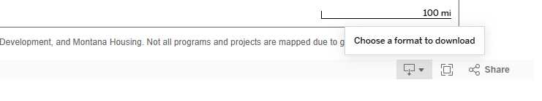

A list of options will appear. Click “Crosstab” to download the results in an Excel format.

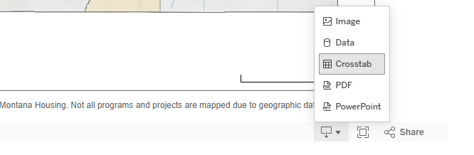

The following popup will appear:

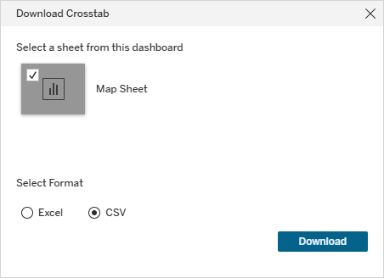

Select the CSV radio button. An Excel spreadsheet will appear populated with the requested information. Click “Download,” and the results will open in Excel.