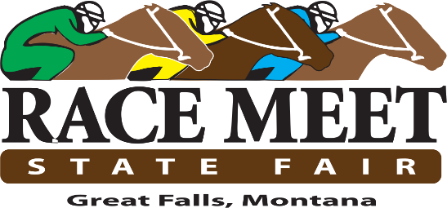

Great Falls Turf Club Funding Request

Date: April 16, 2026
To: Montana Board of Horse Racing
From: Chad Swift, Board Member, Great Falls Turf Club
Subject: Supplemental Funding Request for Great Falls 2026 Race Meet

To cover outstanding debts and keep the Great Falls Race Meet moving forward, the Great Falls Turf Club would like to request a one-time payment of $175,000. This money will be used to set a stable foundation for the future and ensure the health of the State Fair Meet moving forward.

Respectfully,

Chad Swift
President, Great Falls Turf Club
(406) 868-5657
floorsandmoremt@gmail.com

