A Meeting of the Montana Heritage Commission
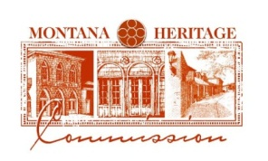
AGENDA
Thursday, November 14, 2024
12:00 PM - 1:00 PM
VIA ZOOM

12:00 Call to Order/Roll Call

Notice of Meeting

12:05 Discussion on Board Leadership

12:10 Discussion on Stonewall Hall Advisory Committee
12:30 Public Comment
12:40 Vote on Stonewall Hall Approval
12:50 Public Comment
12:55 Next Meeting
1:00 Adjourn

